Viscosity project summary_Section 2_ML

398 cP

Table of content

**Standard 398.5 cP 2**

Set: Half 2

Set: Half (unorderedT) 12

Set: 1 19

Set: 1 (unorderedT) 29

Set: 1 (LCB) 36

Set: 1 (ver4) 40

Set: 1 (distributed) 43

Set: 1 (amended - real LIN) 49

# 

# Standard 398.5 cP

Machine learning segment

## Set: Half

Observation of trends

Observation 1: GPR - scaling: Division and LIN - scaling: Multiplication and Division

Once an ‘optimal’ set of parameters are attained, it will double check one time to confirm, then continue to explore parameters. The ‘confirmation’ stage usually occurs in trial 5 or 6 of the 10 trials and it can continue to suggest parameters that deviate quite far from the ‘optimal’ set of parameters.

Observation 2: GPR - scaling: Multiplication

Once an ‘optimal‘ set of parameters are attained, it will remain the same for the rest of the 10 trials. The ‘optimal’ set of data is usually attained in trial 5 or 6 too, similar to when division is used for scaling.

Observation 3: GPR - scaling: Without and LIN - scaling: Without

A converging trend is observed for percentage error. The first 2 trials’ %error usually falls between 5-6% but it converges towards 0 from trial 2-9. However, trial 10 deviated from the consistency observed between trial 2-9. Unlike the trials with GPR-multiplication used in the scaling code (stays the same after ‘optimal’ parameters are found), the parameters continue to change slightly after the ‘optimal’ set of parameters are attained. For that, GPR without scaling can be said to be somewhere between when division and multiplication are used for the scaling parameters (continues to ‘explore’ moderately after ‘optimal set’ is found).

LIN scaling: division

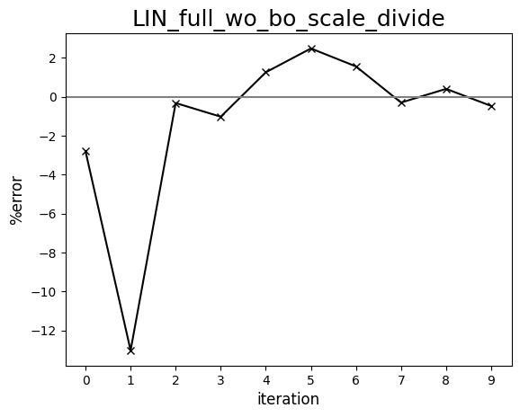

LIN scaling: multiplication

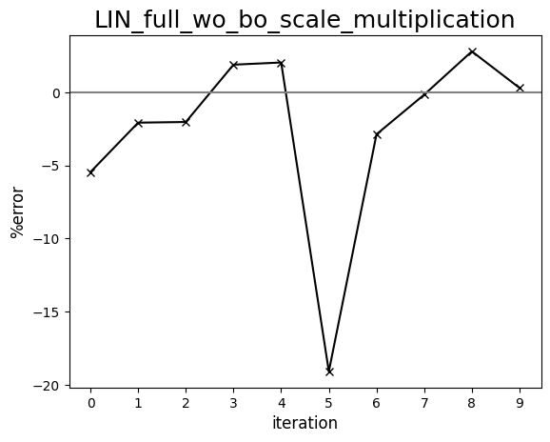

LIN scaling: without

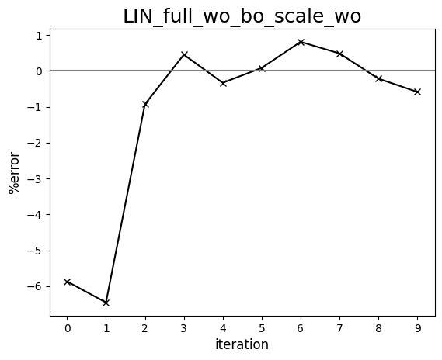

GPR scaling: division

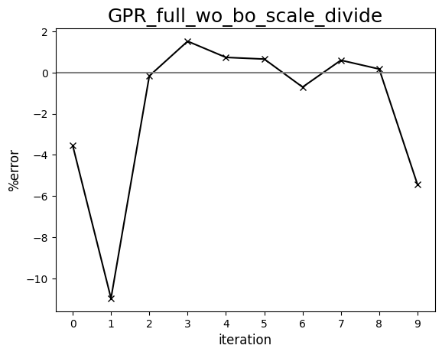

GPR scaling: multiplication

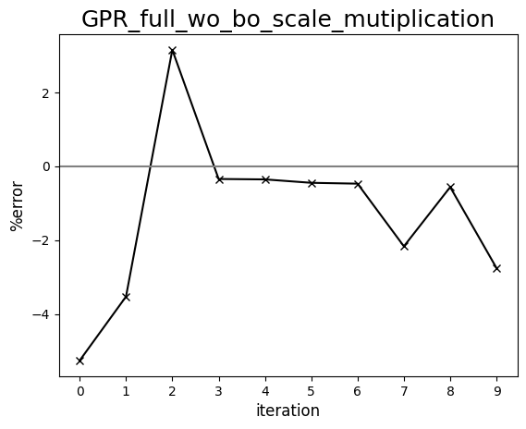

GPR scaling: without

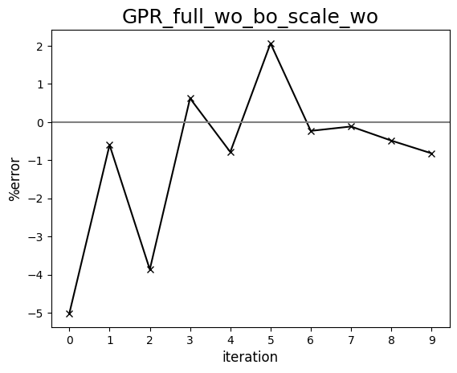

Diagram comparing human-driven and ML test trials (398 cP, set:half)

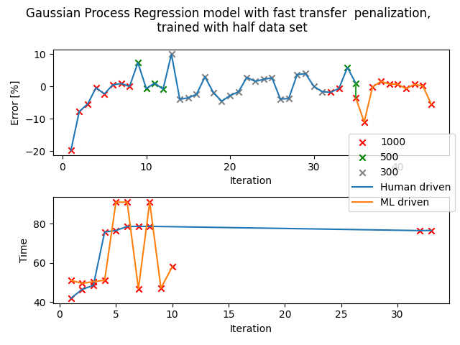

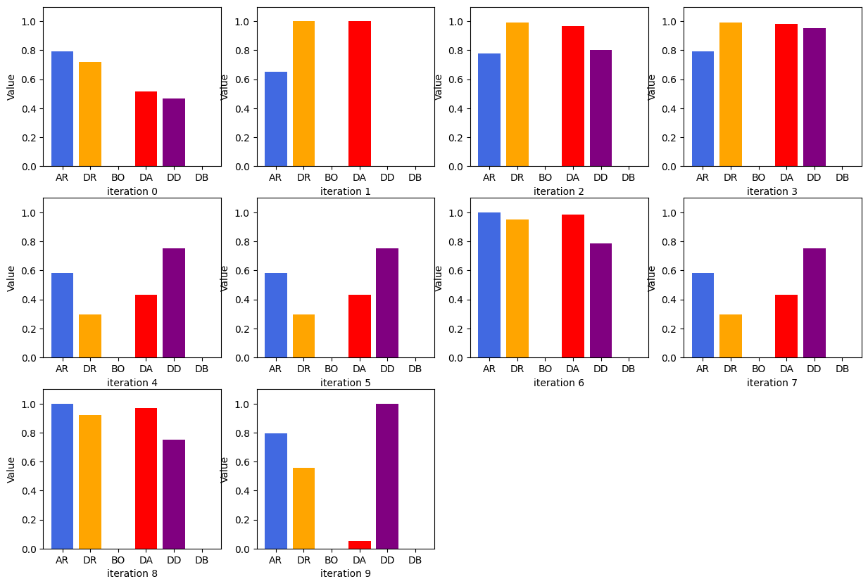

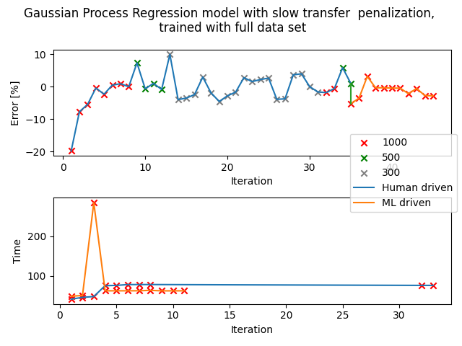

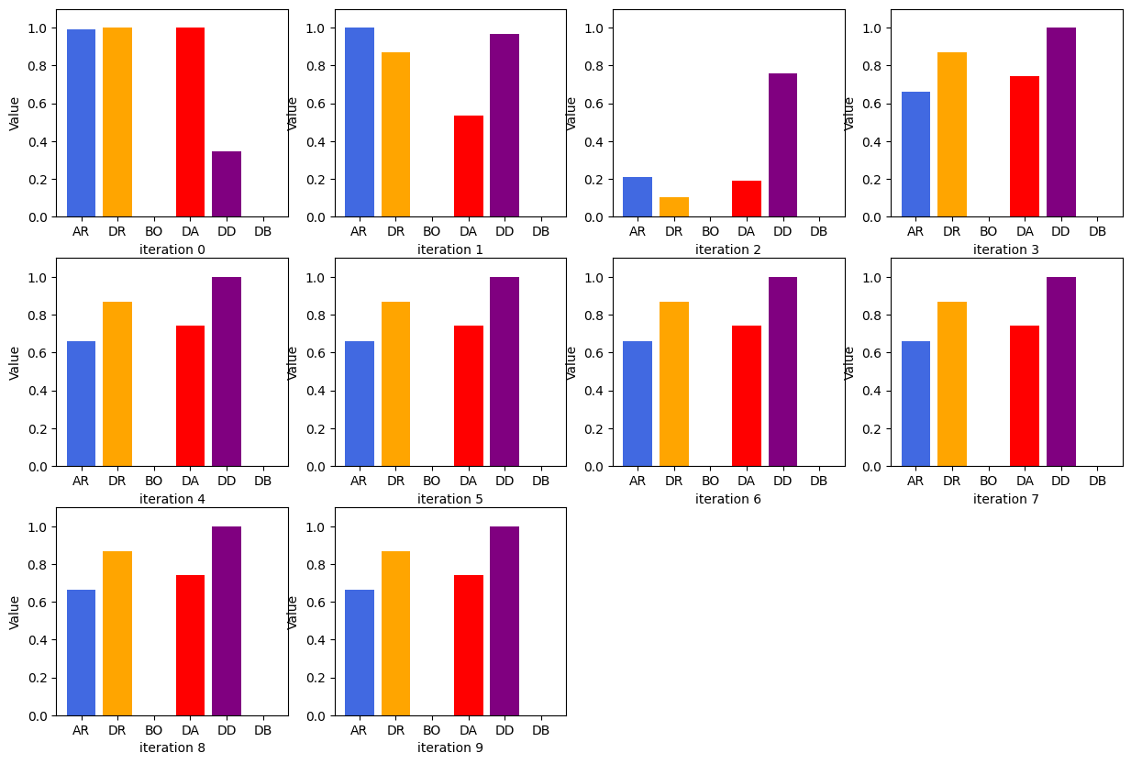

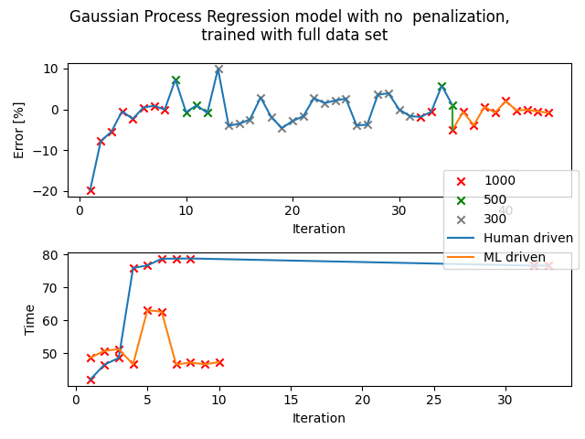

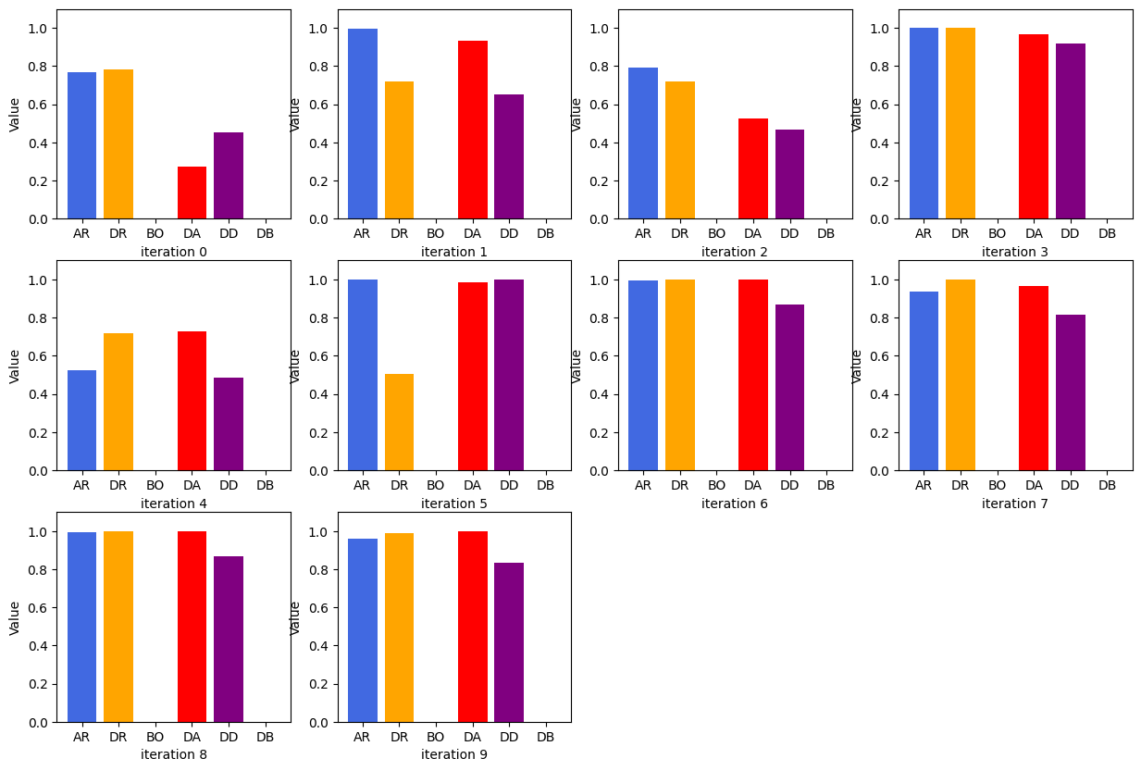

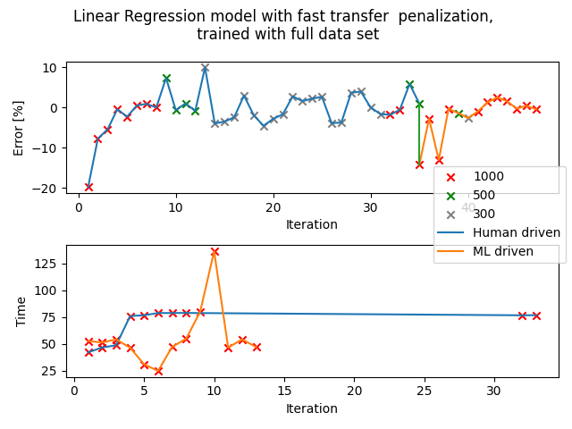

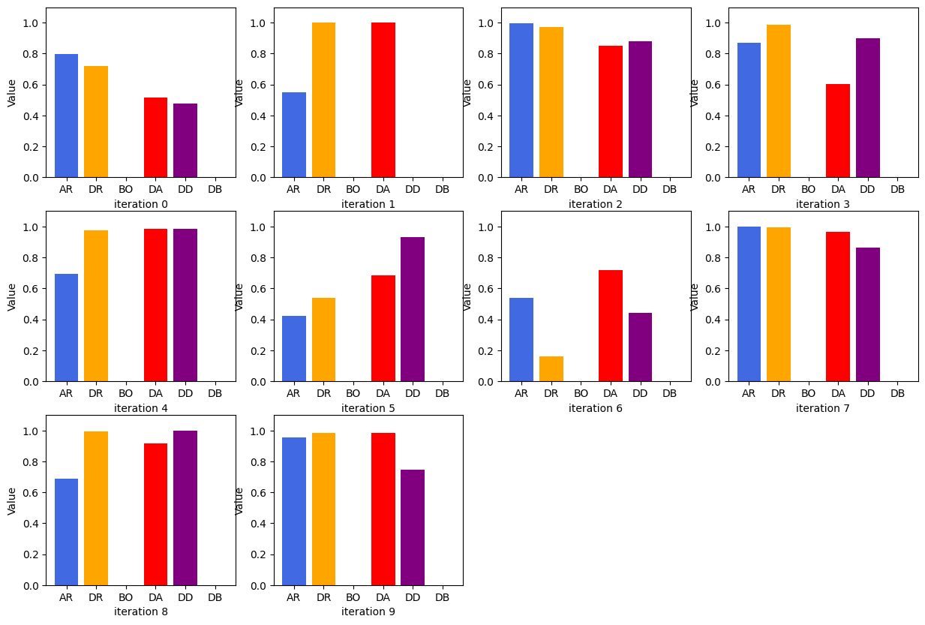

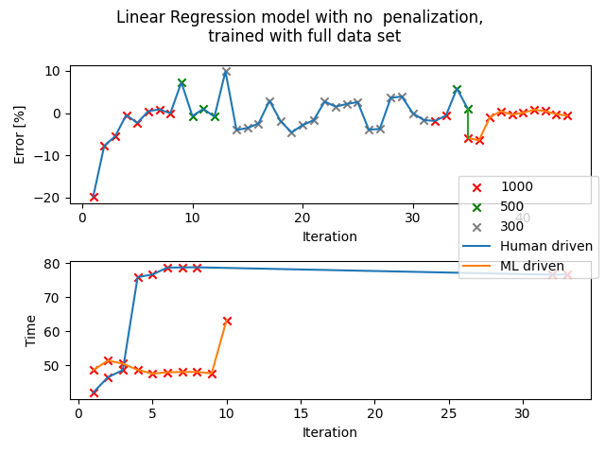

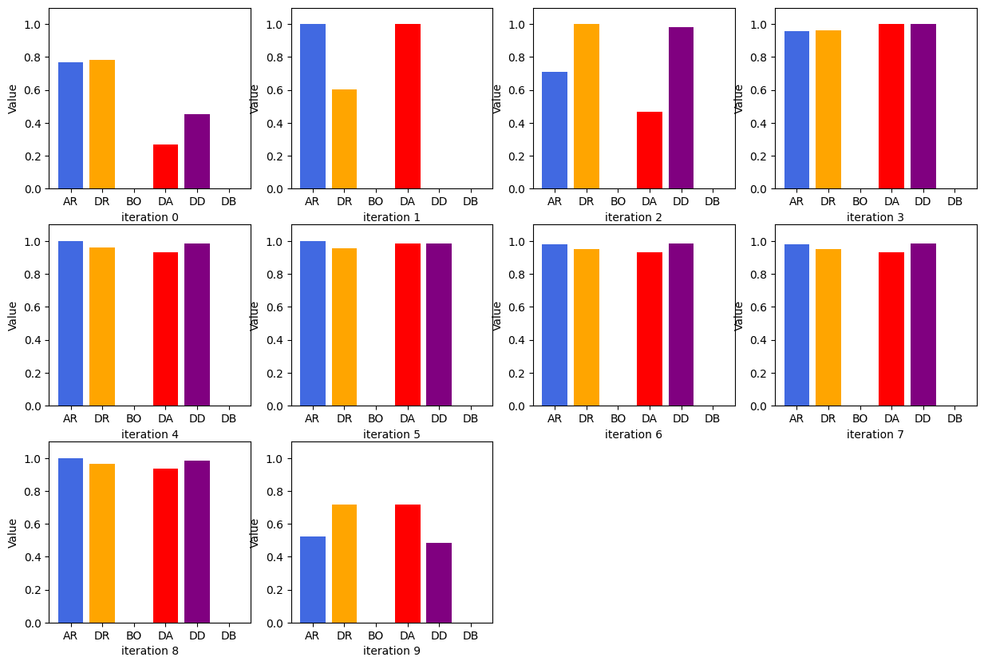

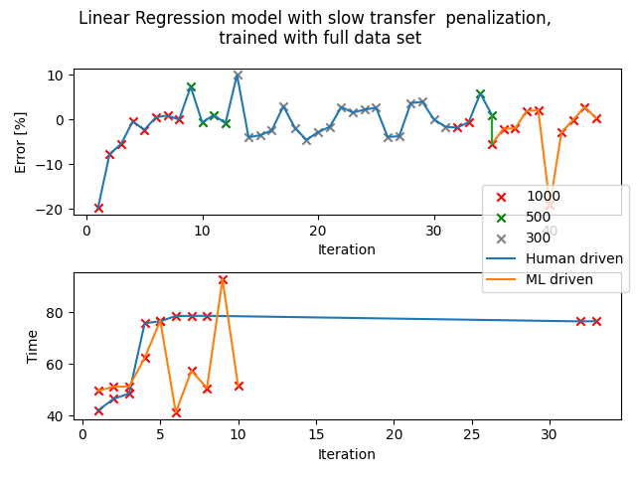

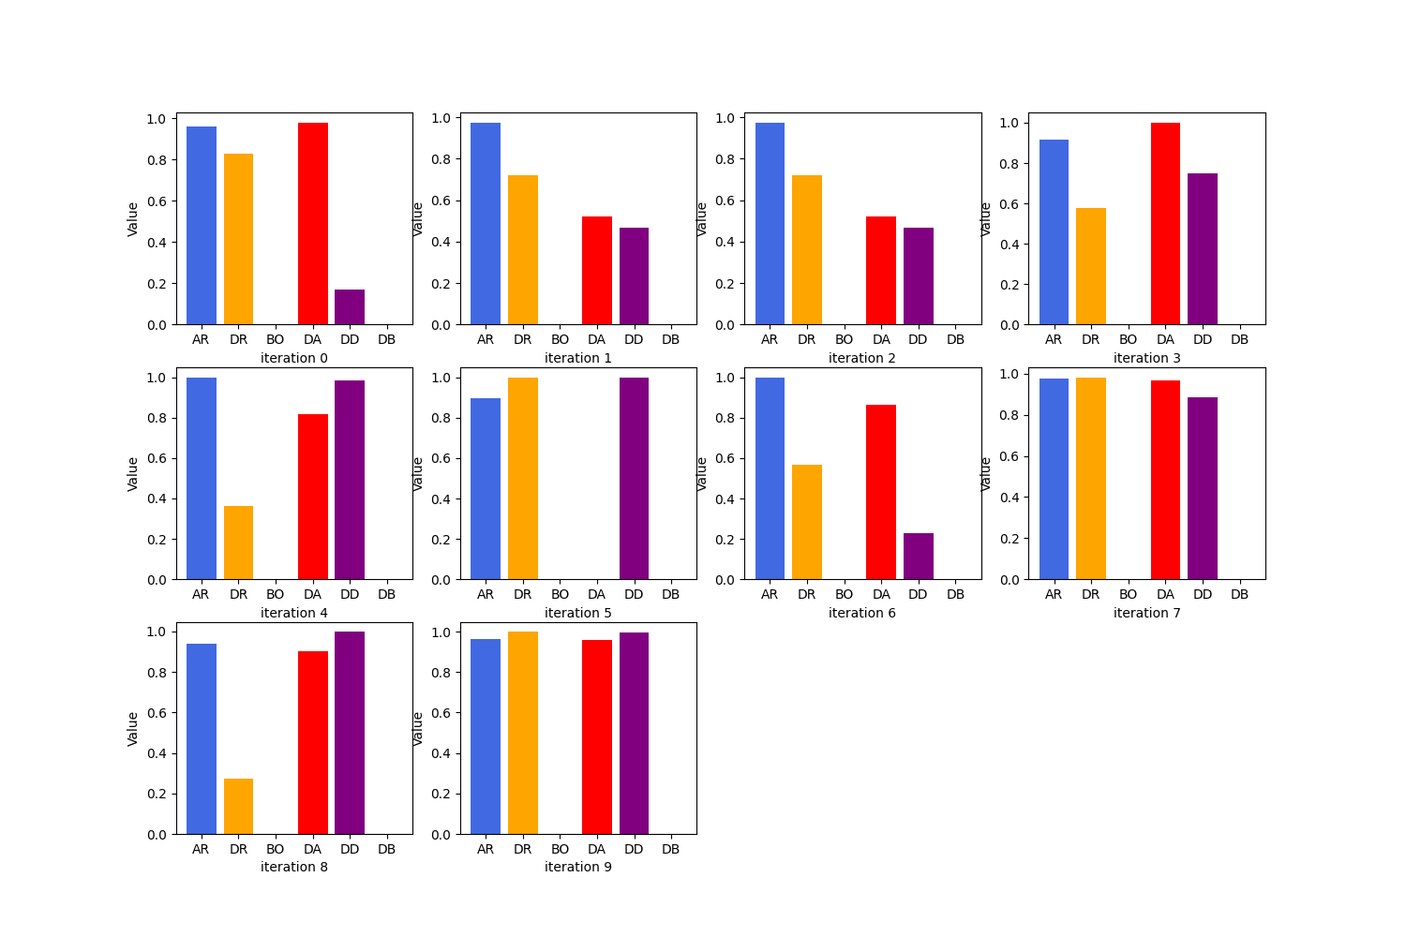

## Set: Half (unorderedT)

Observation of trends

Observation 1: GPR - scaling: multiply

Some repetitions in the sets of parameters generated but it does show a decent amount of variation (set: 1 trials often have more repetition, GPR especially - sometimes all 10 sets of parameters are the same). However, the sets of parameters generated do not seem to align with the penalization used. When it is changed to multiply, it should penalise slower transfer times but this iteration has more long time trials as compared to GPR - none, which does not have the penalization. The percentage error is not so bad,

Observation 2: GPR - scaling: none

In general, fast and relatively accurate trials, around 7 out of 10 trials are within tolerance of 1000uL. The time taken for transfer is similar to the average time taken for human driven section trials (standard calibration).

Observation 3: LIN - scaling: multiply

Slow transfer penalization seems to work on LIN. Overall short transfer time, not very accurate as seen in the data, only 5 to 6 out of 10 trials are within tolerance of 1000uL.

Observation 4: LIN - scaling: none

Accuracy is similar to LIN - multiply but much longer trials on average, a few trials even reached 200 seconds even though the standard calibration indicates around 80 seconds. However, at the last 5 trials, the model is able to discover sets of parameters that give very accurate transfer even though the 5 sets of parameters are very different, time ranges from 56s to 200s. (This shows that this iteration is prioritising low percentage error instead of shortening transfer times) Thus, one can suspect, in the long run this model can provide interesting parameters that are accurate.

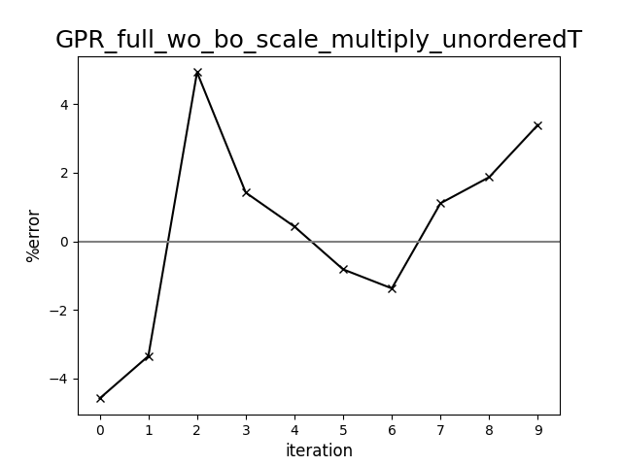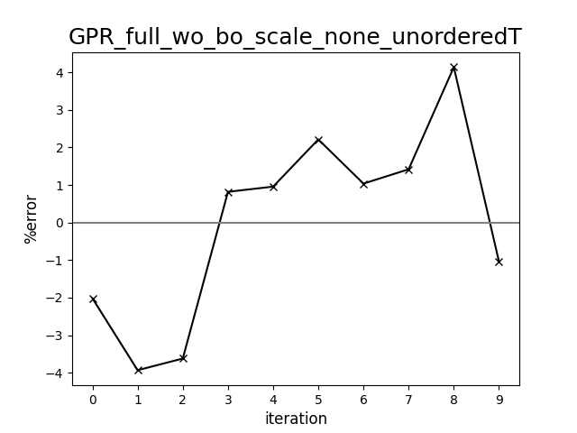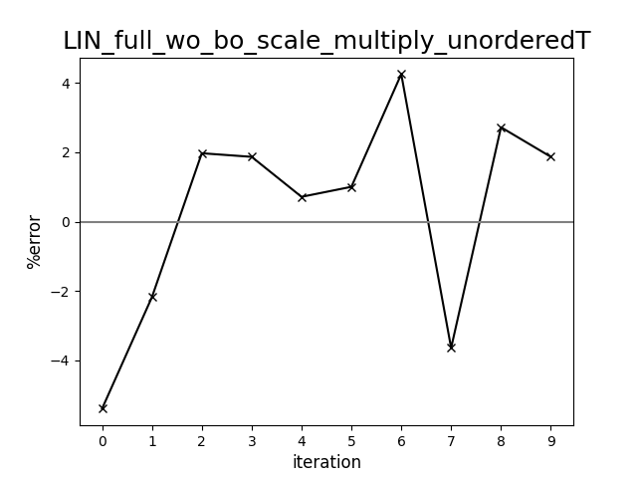

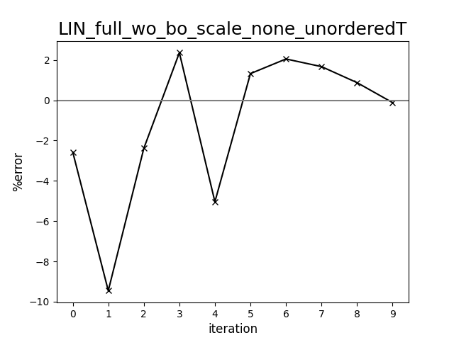

Diagram comparing human-driven and ML test trials (398 cP, set:half, unorderedT)

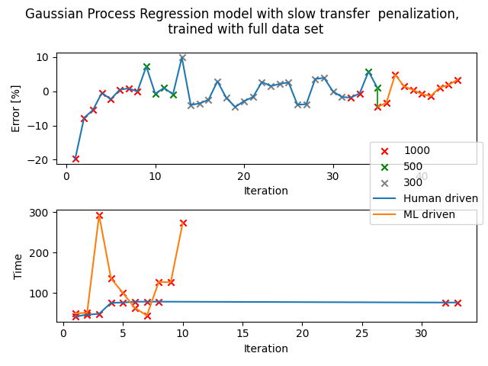

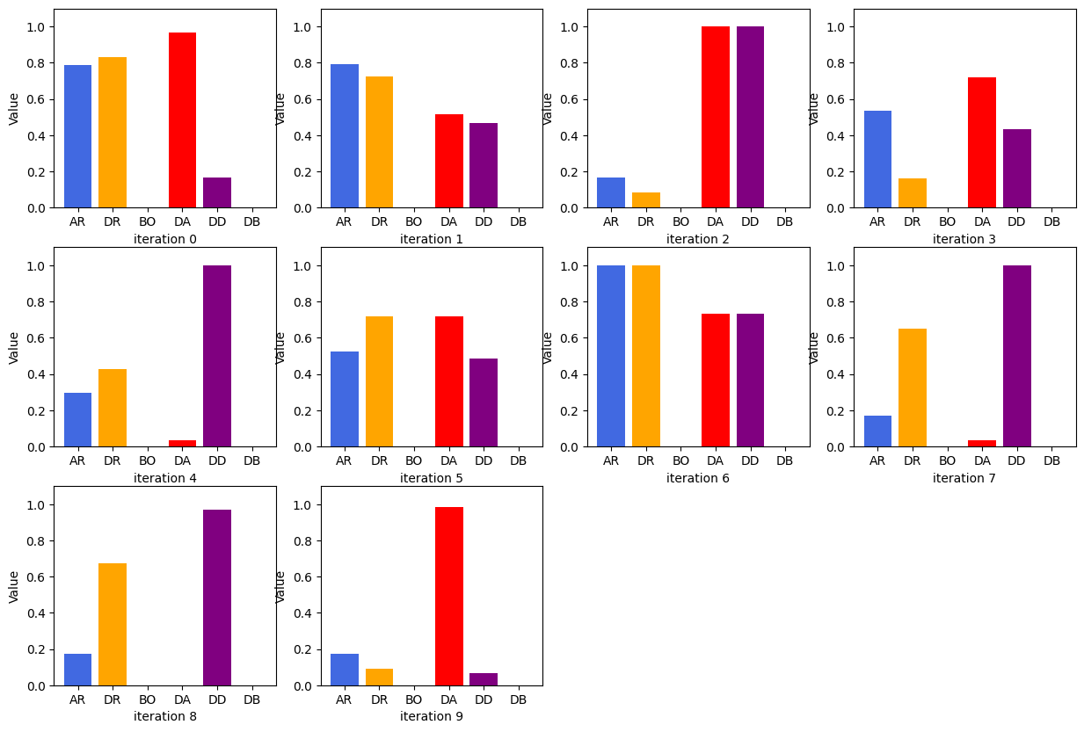

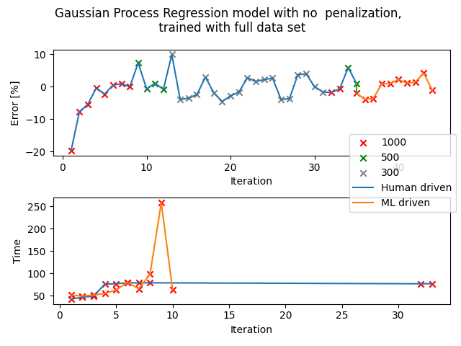

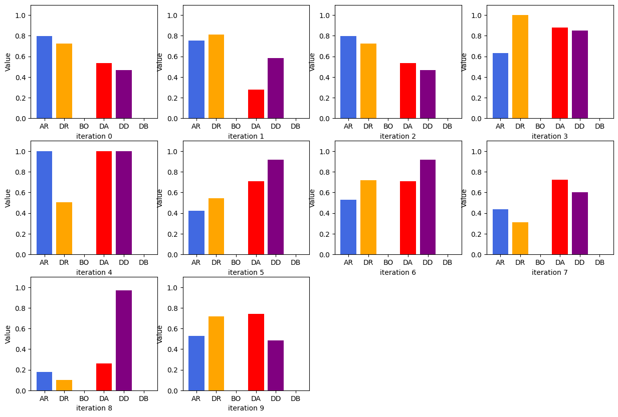

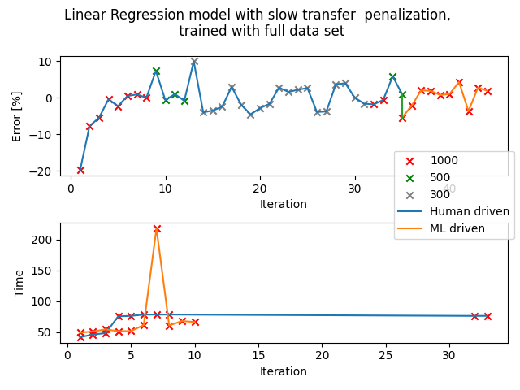

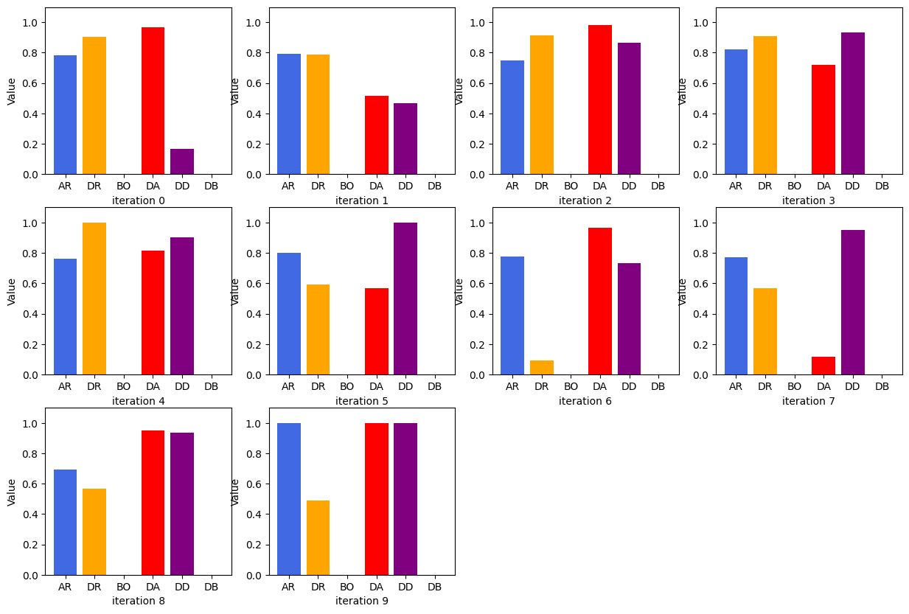

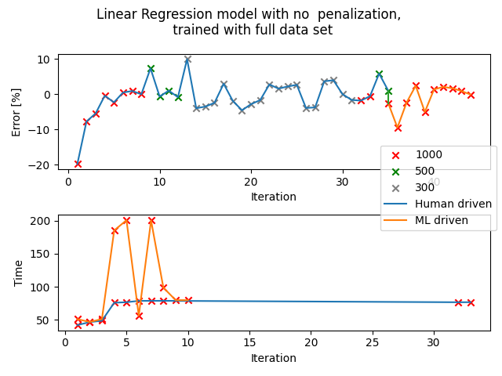

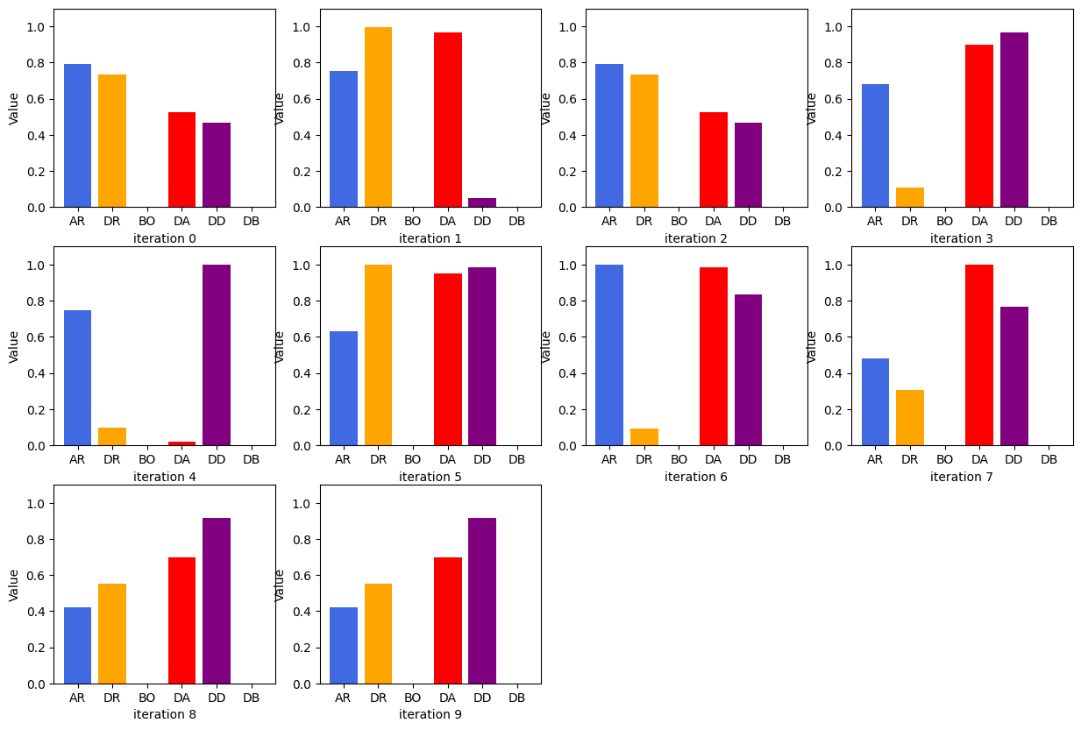

## Set: 1

Observation of trends

Observation 1: LIN - scaling: Without and LIN - scaling: Multiplication

Once an ‘optimal’ set of parameters are attained, it will double check once or twice to confirm, then continue to explore parameters. The ‘confirmation’ stage usually occurs in trial 5 or 6 of the 10 trials and it can continue to suggest parameters that deviate quite far from the ‘optimal’ set of parameters.

The error percentage fluctuates slightly between -2% to 2%, which is within tolerance of 1000uL. The sets of parameters are the most random out of the 3 observations (but does not have very big percentage error)

Observation 2: GPR - scaling: Division and LIN - scaling: Division

The sets of parameters generated are all prioritising faster transfer duration, neglecting the percentage error generated. On average, the percentage errors are all around -11 to -12% for both LIN and GPR models. The parameters do change but very slightly, all targeting at faster transfer rate.

Observation 3: GPR - scaling: Without and GPR - scaling: Multiplication

Both iterations show a lot of repetition in the parameters suggested. For scaling: without, the parameters are the same from trial 1 to trial 2 and also the same from trial 3 to trial 10. For scaling: without, the percentage error is an average of -3% while scaling: multiplication has percentage error of -2%. The sets of parameters suggested for GPR scaling: without and multiplication can be said to be almost identical.

Repetition is commonly observed for trials that use the GPR model, this pattern is consistent for both set: 1 and set: half.

It is worth noting that there are some sets of parameters that are repeated for many different iterations. It might help in determining the optimal set of data in the future. A few of such set of parameters are: (AR,DR,AD,DD)

* 52.3, 47.5, 3.1, 2.8
* 66.0, 66.0, 0.0, 6.0

GPR scaling: divide

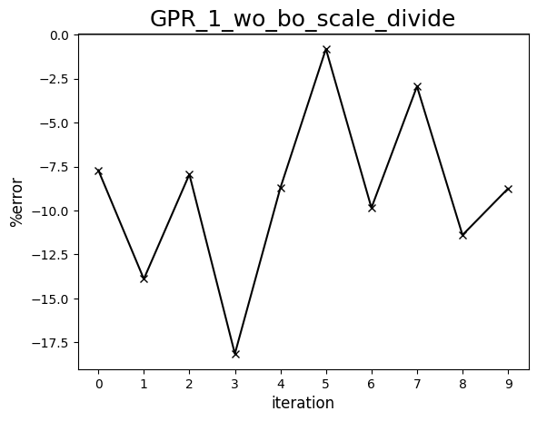

GPR scaling: multiplication

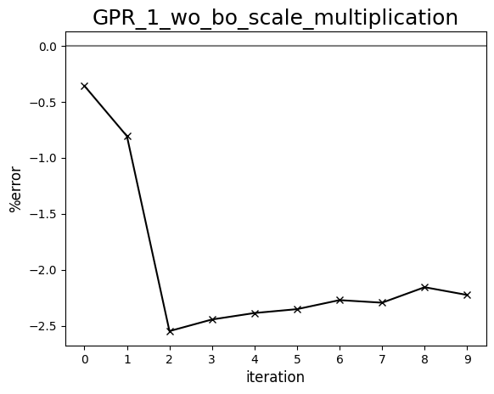

GPR scaling: without

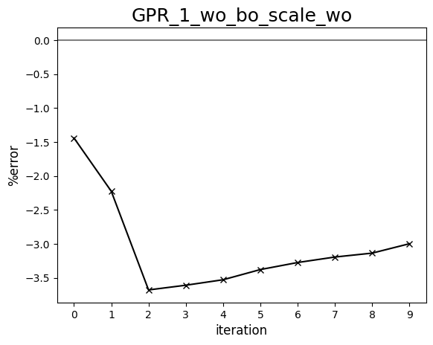

LIN scaling: divide

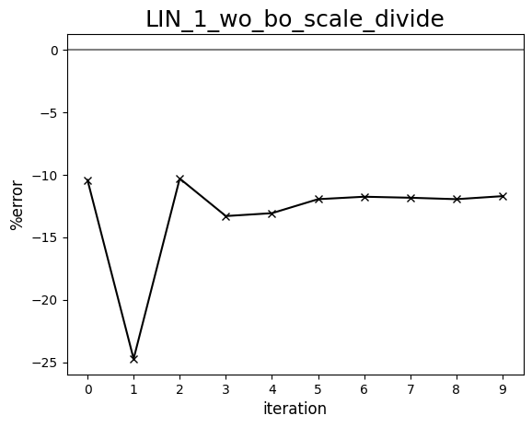

LIN scaling: multiplication

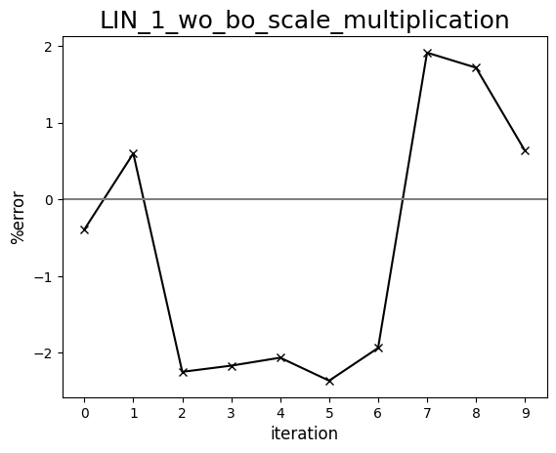

LIN scaling: without

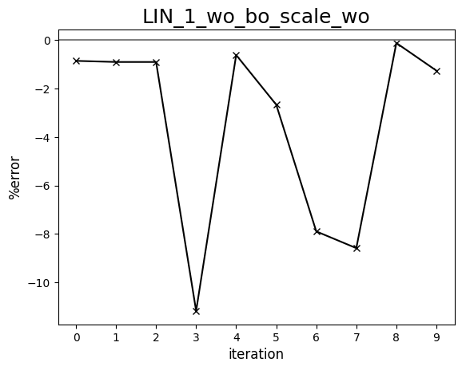

Diagram comparing human-driven and ML test trials (398 cP, set:1)

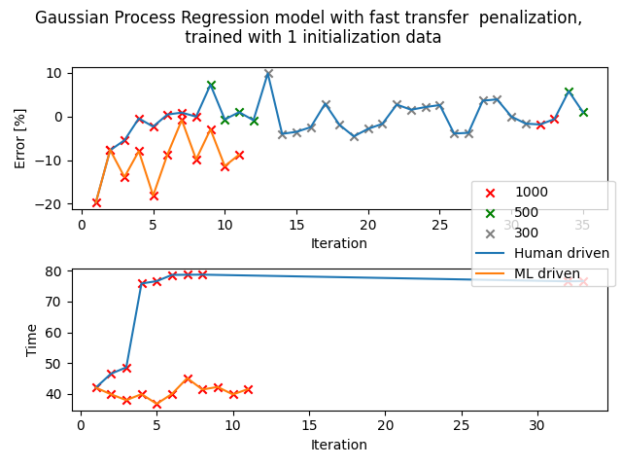

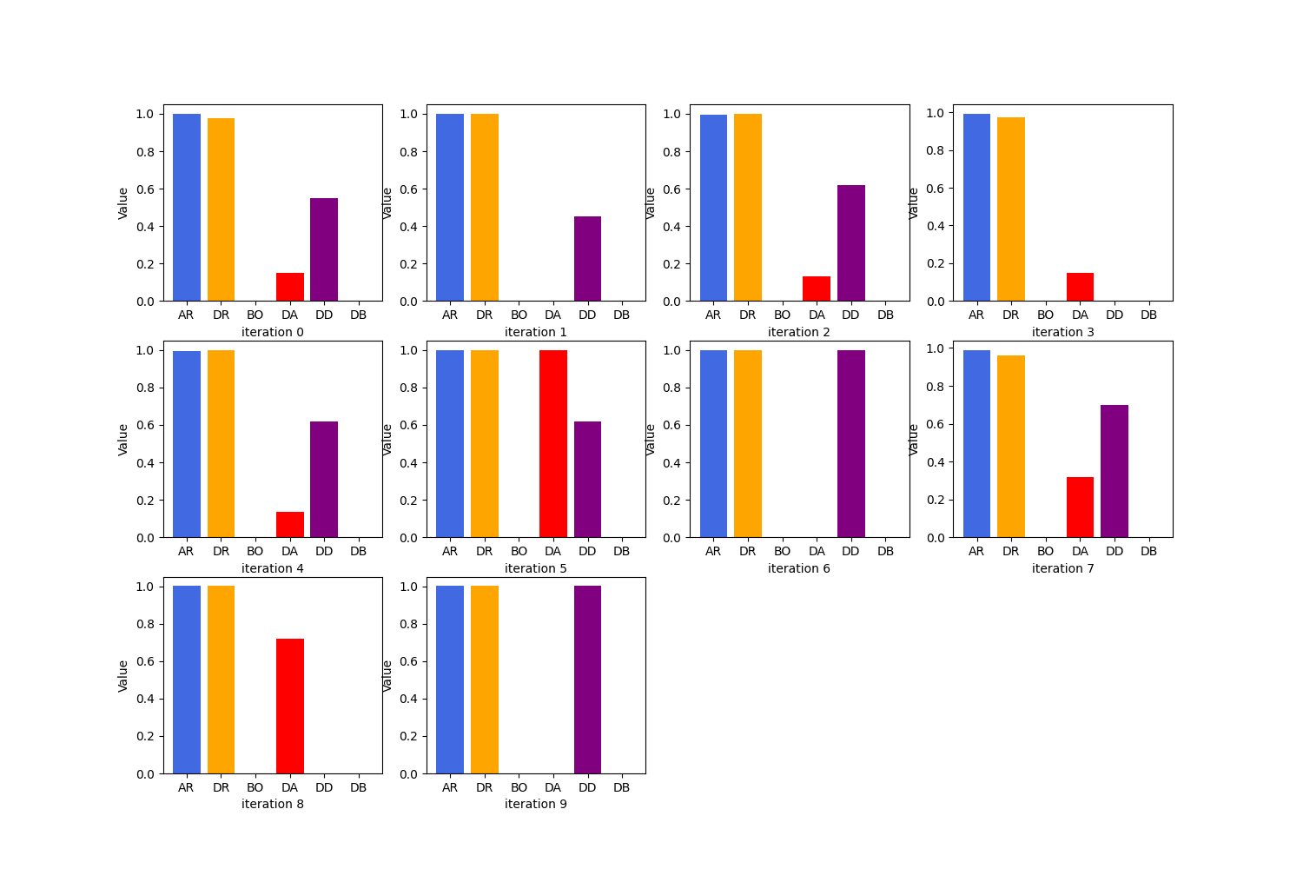

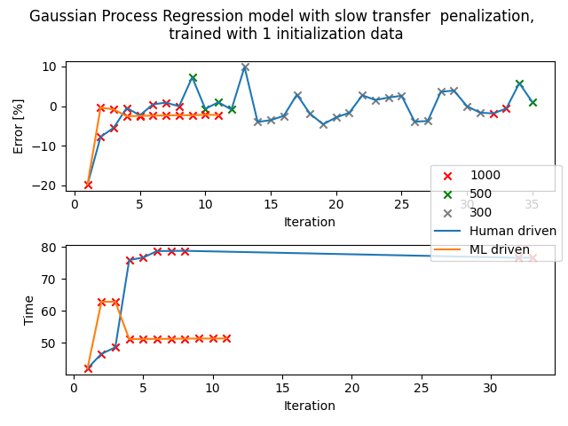

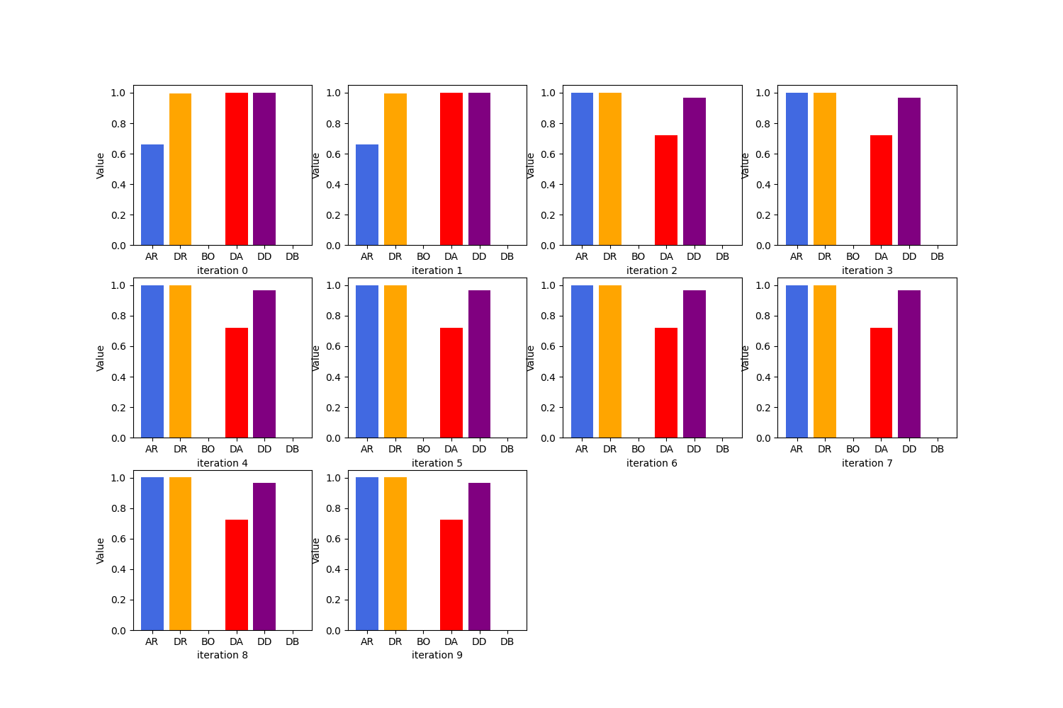

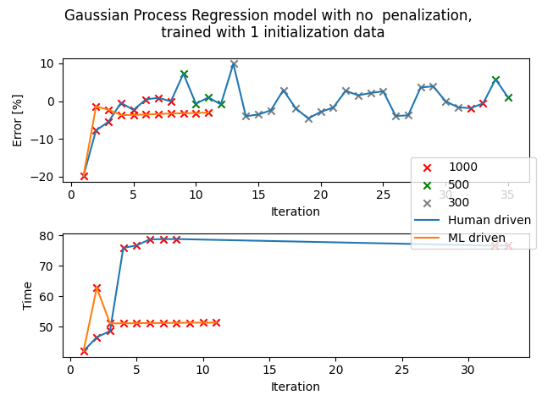

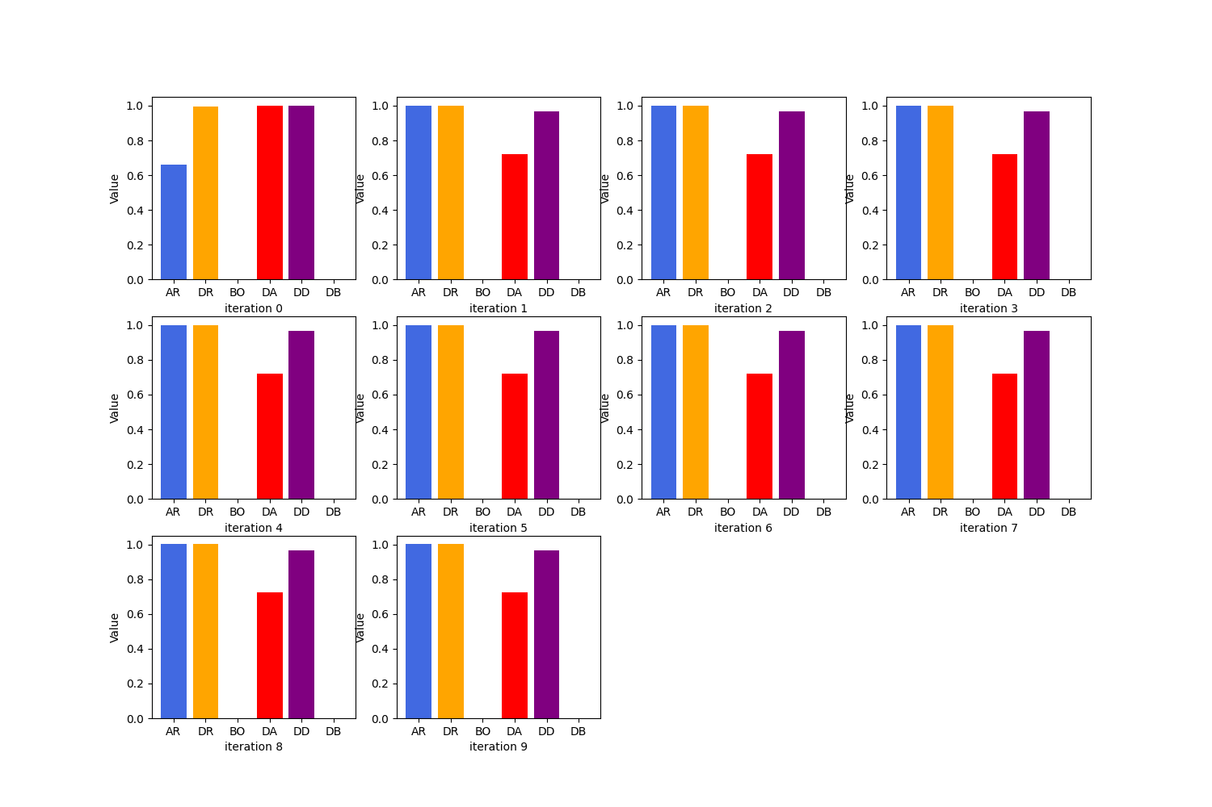

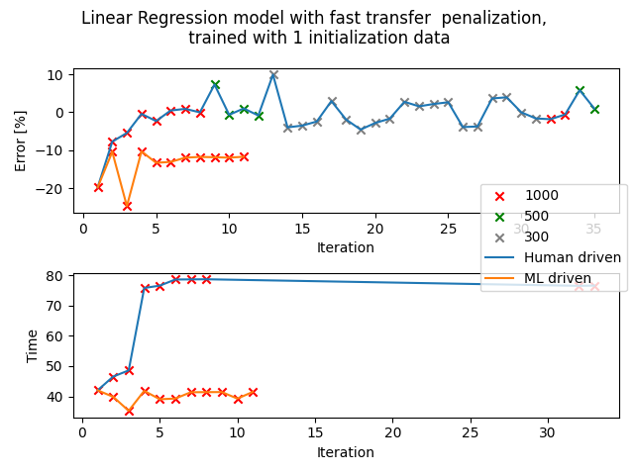

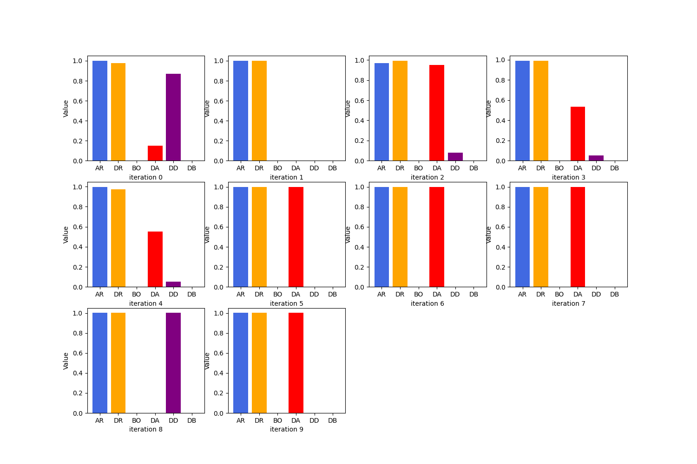

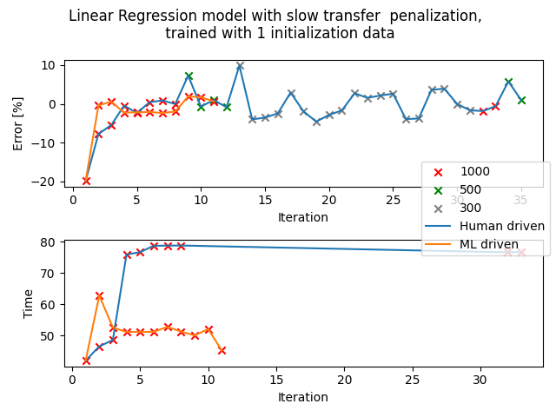

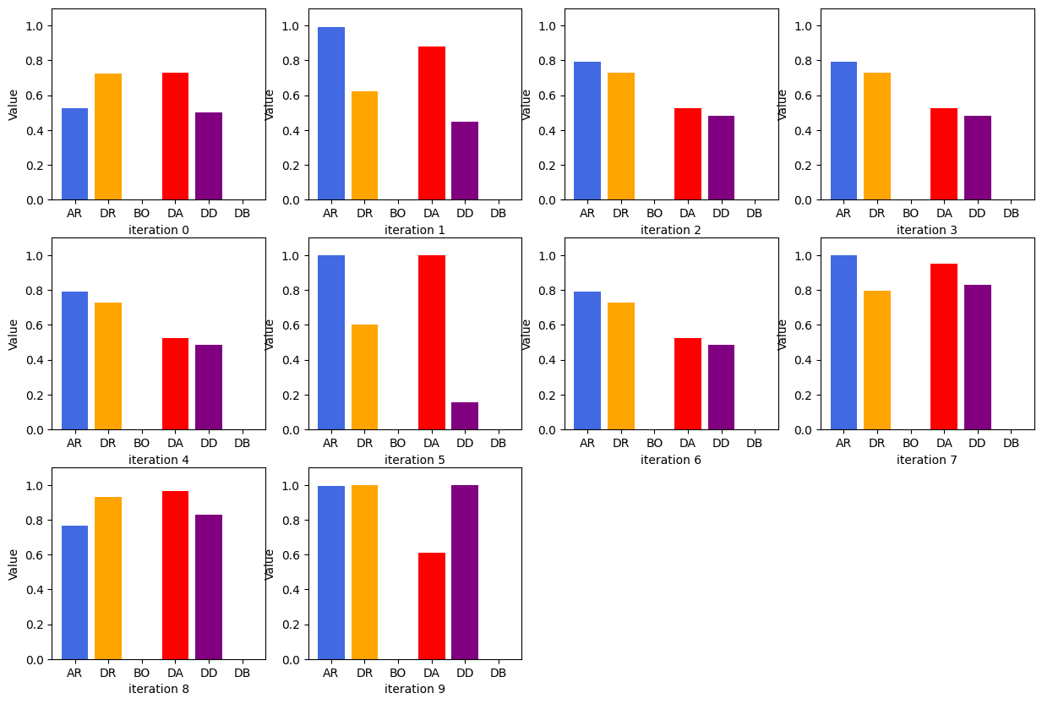

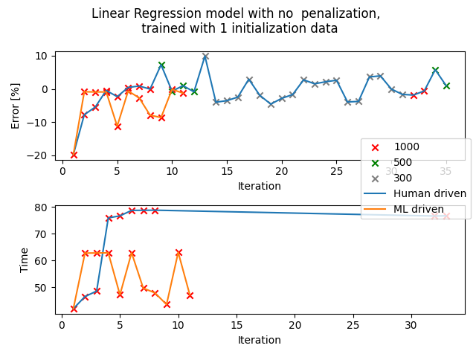

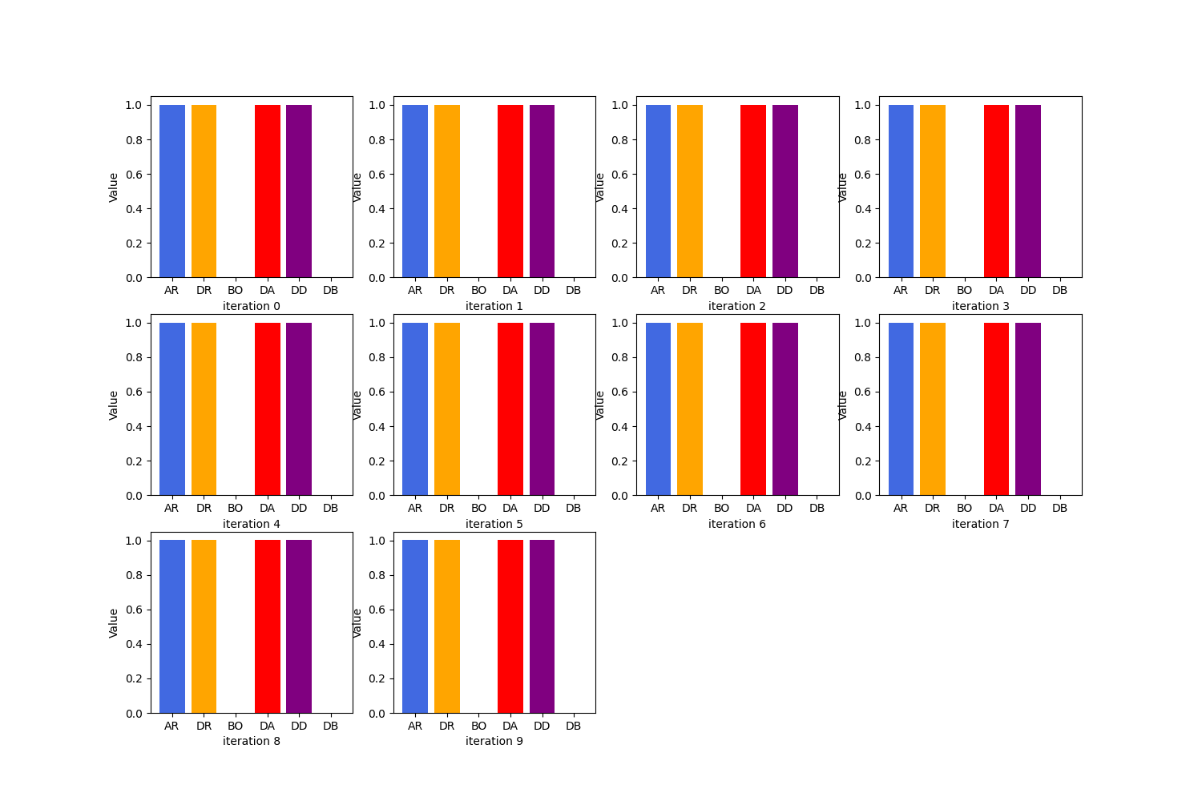

## Set: 1 (unorderedT)

Observation of trends

All iterations

All 4 iterations have sets of parameters that are exactly the same. Basically, the only set of parameters used is: (AR, DR, DA, DD)

34.6, 47.3, 4.3, 2.9

Despite the fact that all 40 trials are identical, the transfers are quite accurate. The percentage error falls between -1 to -2%. All trials took around 62 to 63 seconds, as compared to 80s derived from the standard calibration.

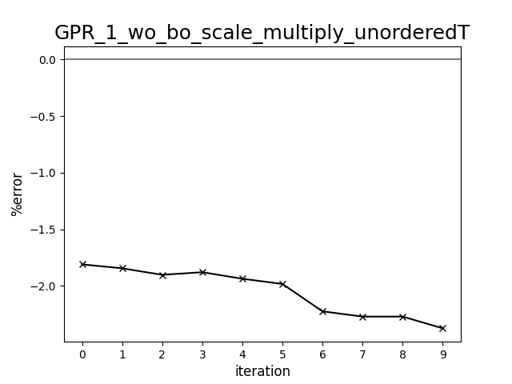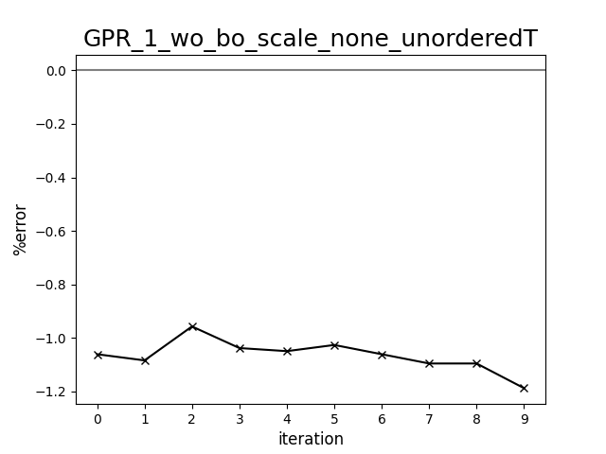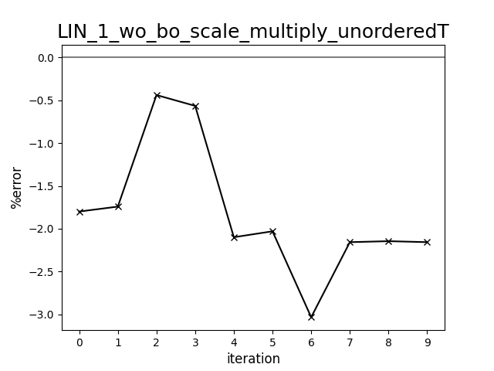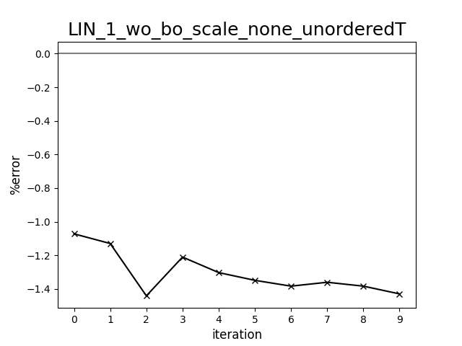

Diagram comparing human-driven and ML test trials (398 cP, set:1, unorderedT)

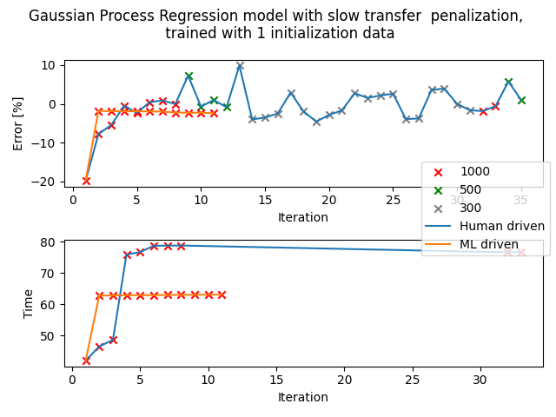



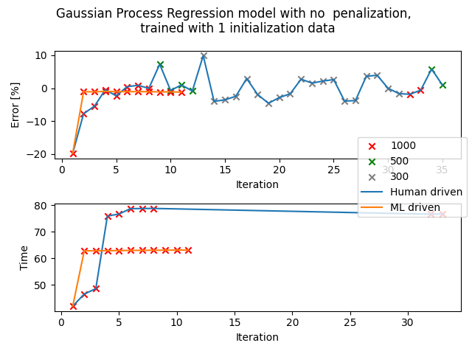



# 



# 

# 

## Set: 1 (LCB)

Observation of trends

Observation 1: LIN - scaling: multiply

All 10 sets of parameters are identical but the percentage error falls within the set boundary of -2 to 2%.

Observation 2: LIN - scaling: none

Similar as above, all 10 sets of parameters are identical but the percentage error falls within the set boundary of -2 to 2%.

Error against iteration diagrams:

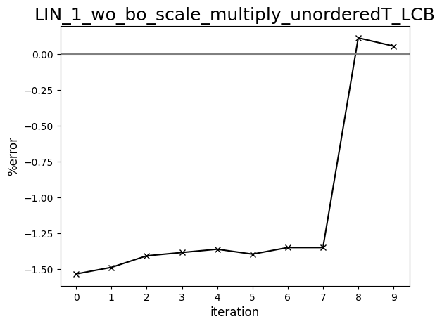

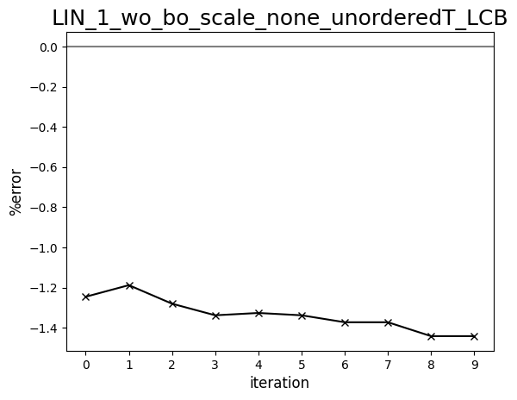

Diagram comparing human-driven and ML test trials (398 cP, set:1, LCB)

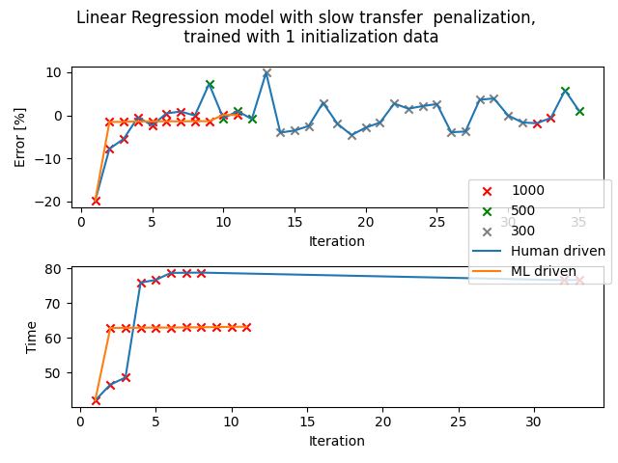



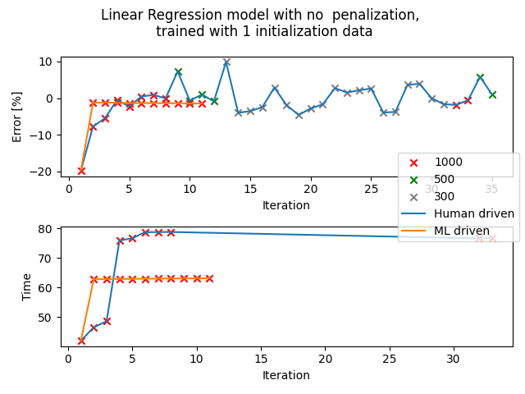



## Set: 1 (ver4)

Observation of trends

Observation: LIN - scaling: none

The first 2 ‘pre-determined’ sets of parameters at the start are not very accurate but the rest of the parameters generated parameters that are within tolerance of 1000uL.

The first 2 sets of parameters:

* first: first set from standard calibration
* Second: half of the first set of parameters

Percentage error against iteration diagram:

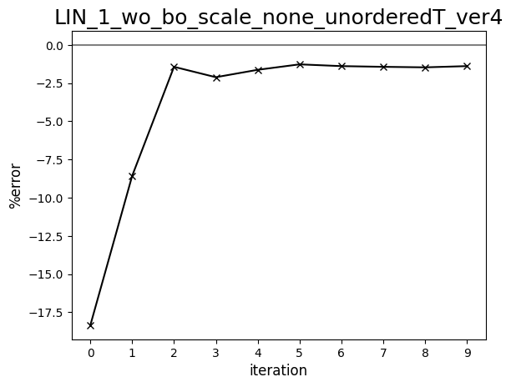

Diagram comparing human-driven and ML test trials (398 cP, set:1, ver4)

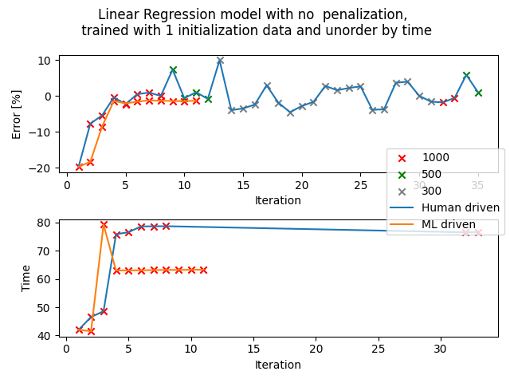

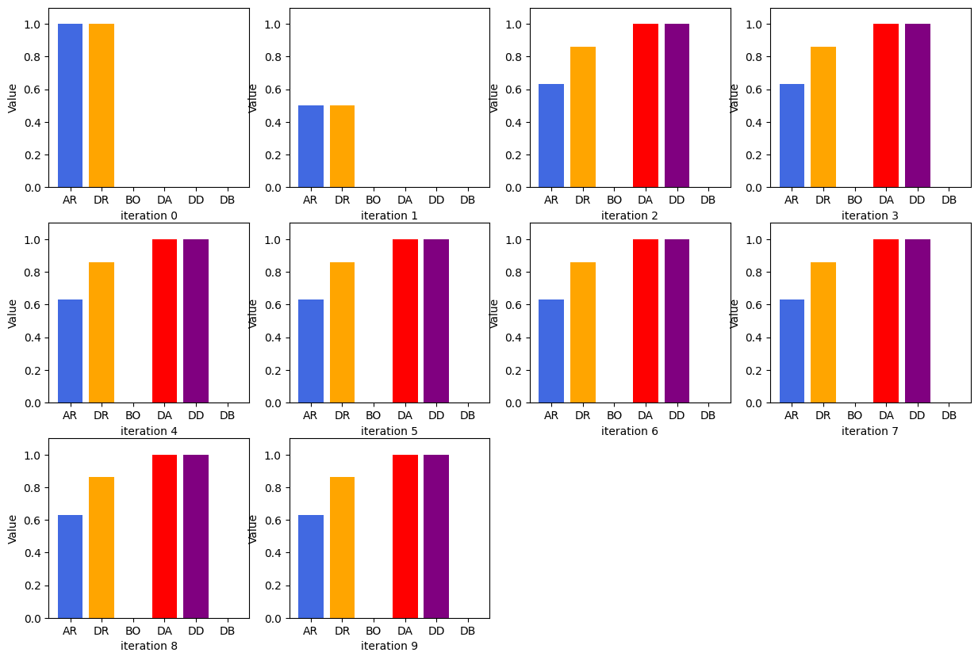

## Set: 1 (distributed)

Observations

Observation 1: LIN - scaling: multiply (slow transfer time penalisation)

Quite a lot of repetition in the sets of parameters generated, maybe it is because it already found the best possible set of parameters. The transfer time is very long (average of 200s) as compared to standard calibration but the percentage error falls within the preferred range of -2 to 2% (1.4 to 1.6%). The slow transfer time penalisation does not seem to work for iteration either.

Observation 2: LIN - scaling: none

Similar as above, a lot of repetition is observed in the sets of parameters generated but this iteration generates a set of parameters that is faster and more accurate than the iteration above. This iteration has an average of -1% and an average transfer time of around 70s.

Observation 3: LIN - scaling: divide

Other than the 2 set points in the beginning, the rest of the sets of parameters are all the same. Despite the lack of variation in the parameters generated, the percentage error is around -0.5% and the transfer time is fast.

Percentage error against iteration diagrams:

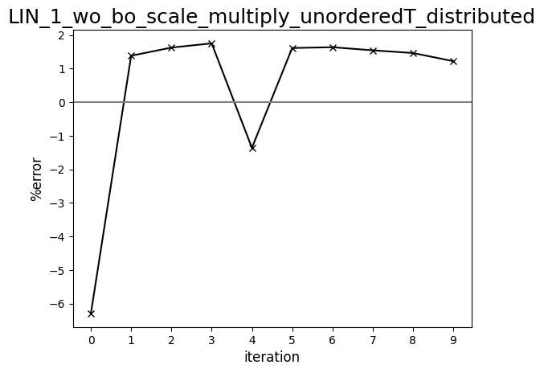

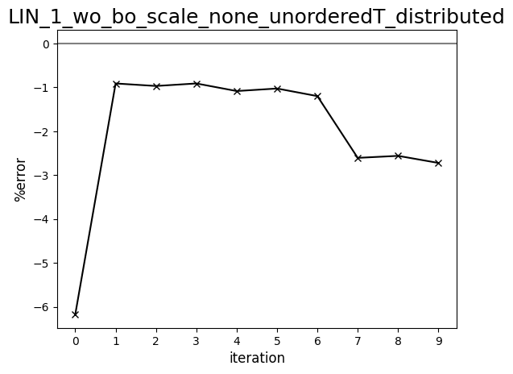

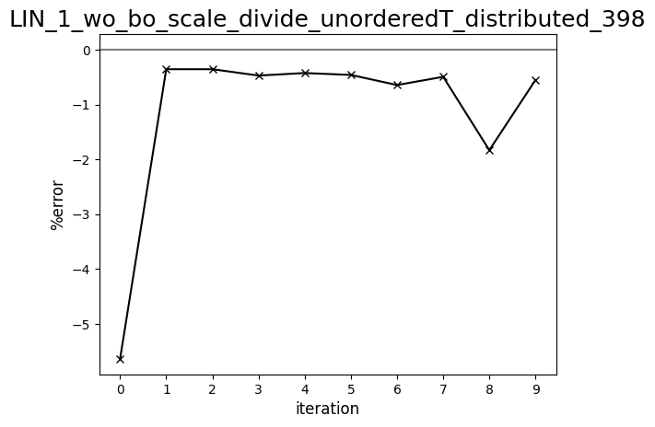

Diagram comparing human-driven and ML test trials (398 cP, set:1, distributed)

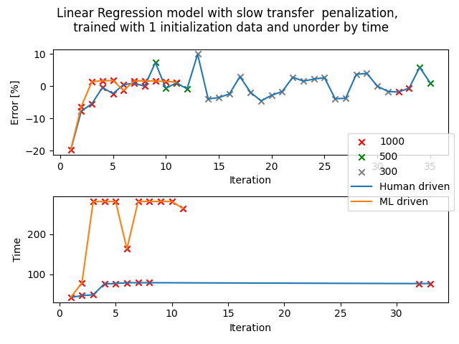

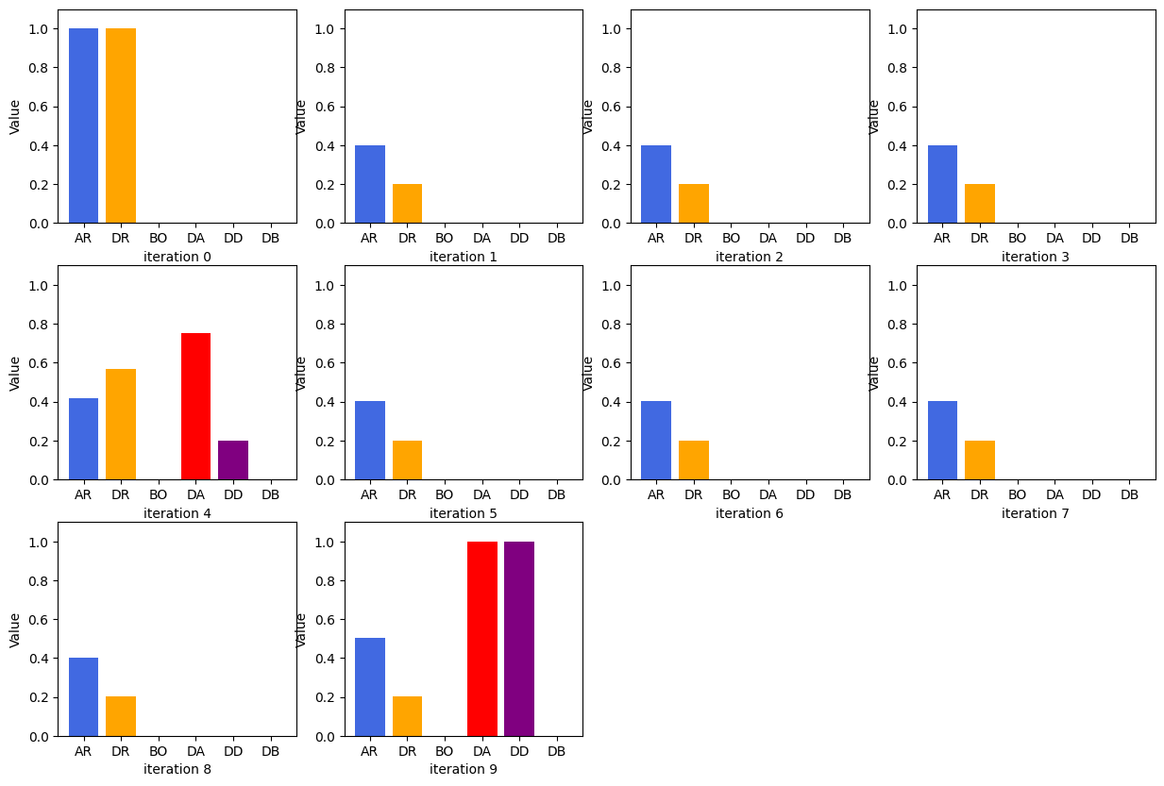

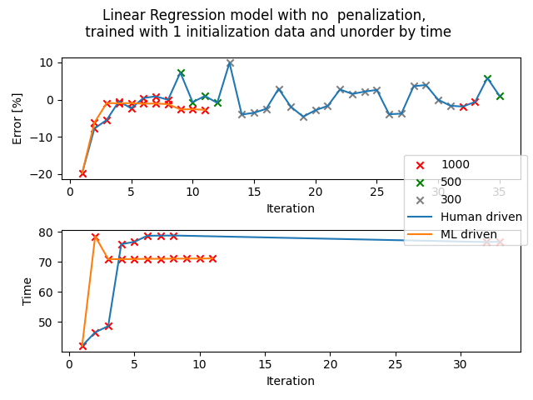

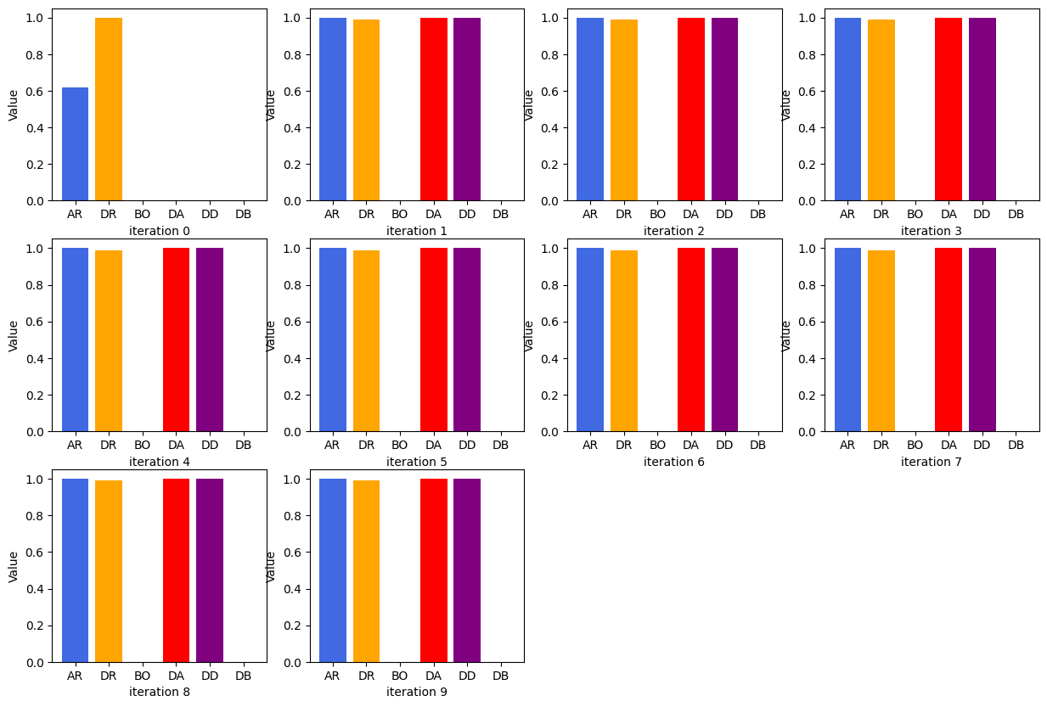

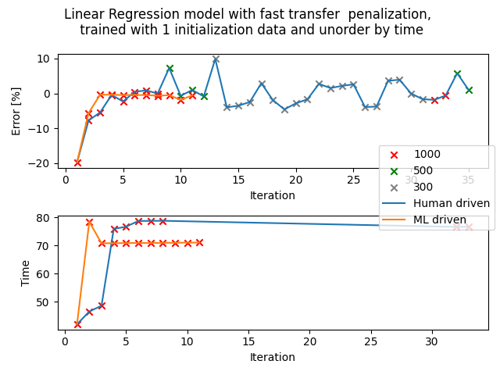



## Set: 1 (amended - real LIN)

Observations

Observation 1: LIN - scaling: divide

Most of the test trials are relatively accurate, their percentage error falls within -2 to 2%. Even though fast transfer time penalization is implemented on this set of test trials, the average transfer time is still pretty fast (but higher than the one derived from standard calibration by around 50s), the penalization did not seem to work. However, it works to our favour, the absolute percentage error and the transfer time are both low.

Observation 2: LIN - scaling: multiply

The percentage error is not as accurate as LIN - scaling: divide, it lingers beyond the preferred boundary and the average transfer time is much slower than both the standard calibration and LIN - scaling: divide. The penalization does not seem to work too.

Observation 3: LIN - scaling: none

Similar to the trials for LIN - scaling: divide, a converging trend can be seen for the percentage error of each iteration. Even though the first few trials have quite long transfer times, eventually it is reduced to the transfer time indicated in standard calibration trials, and then to even lower transfer time while maintaining its accuracy (all the while the percentage error stayed between -2 to 2%).

Error against iteration graphs:

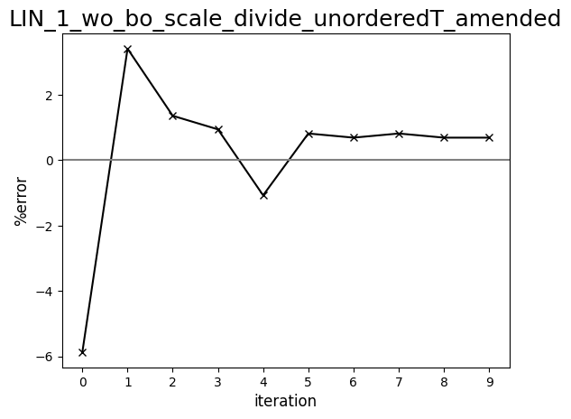

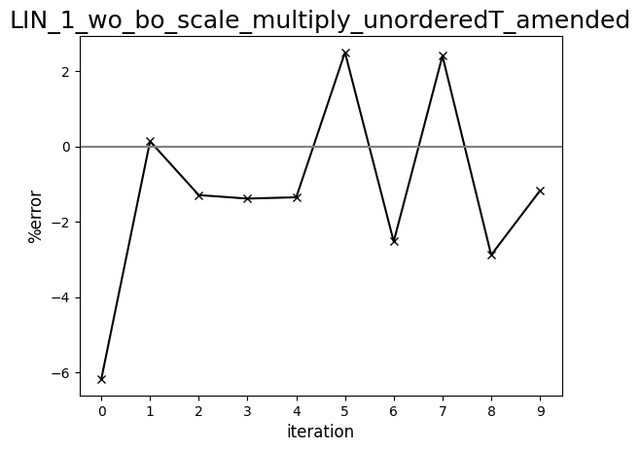

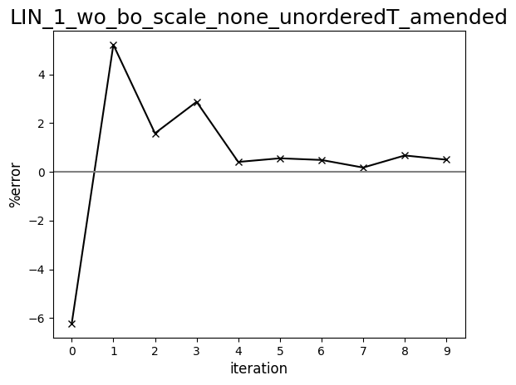

Diagram comparing human-driven and ML test trials (398 cP, set:1, amended)

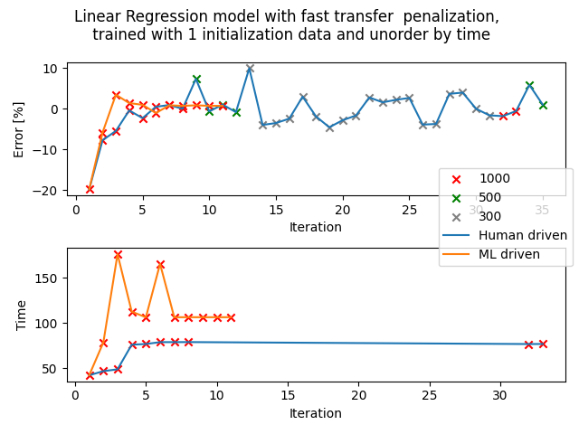

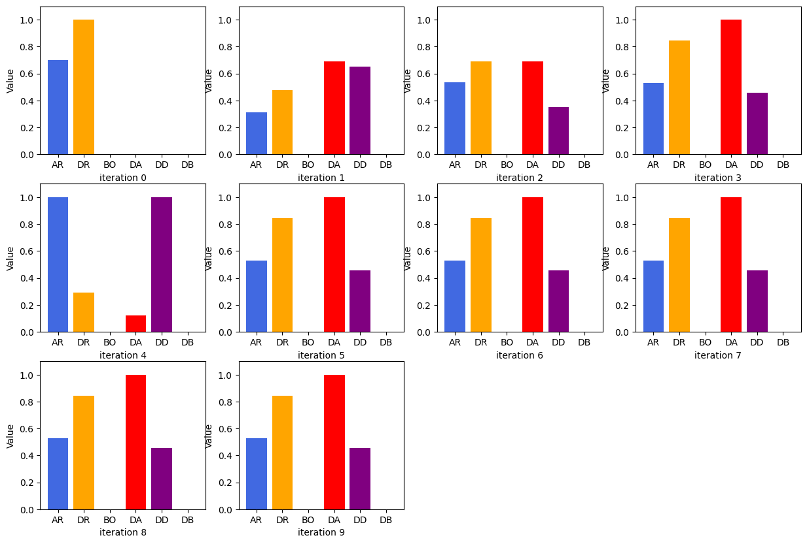

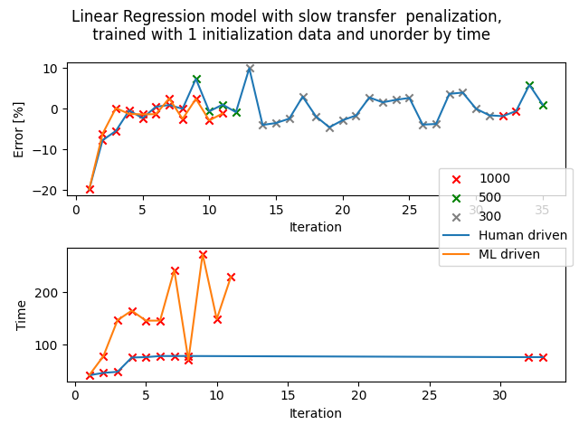

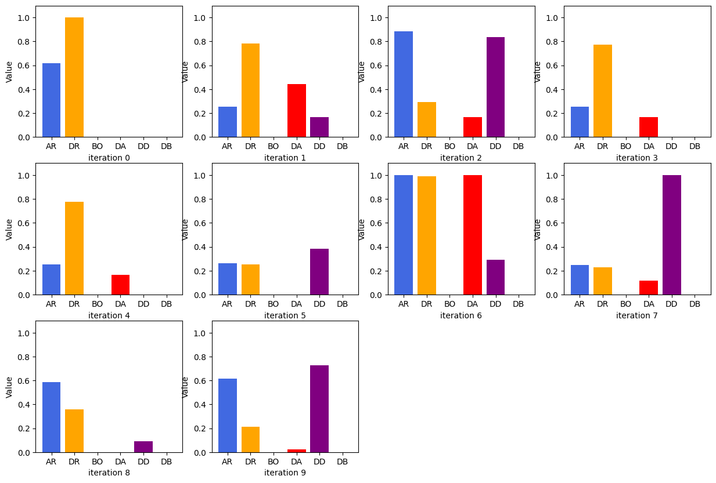

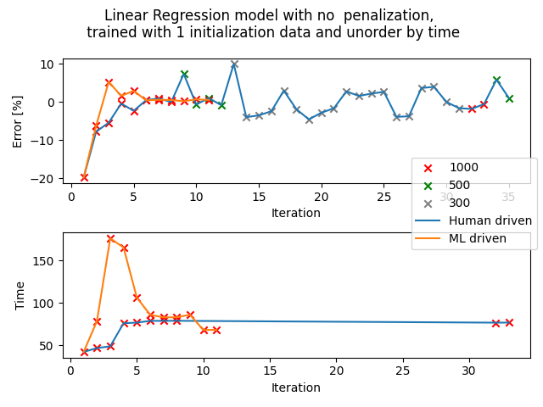

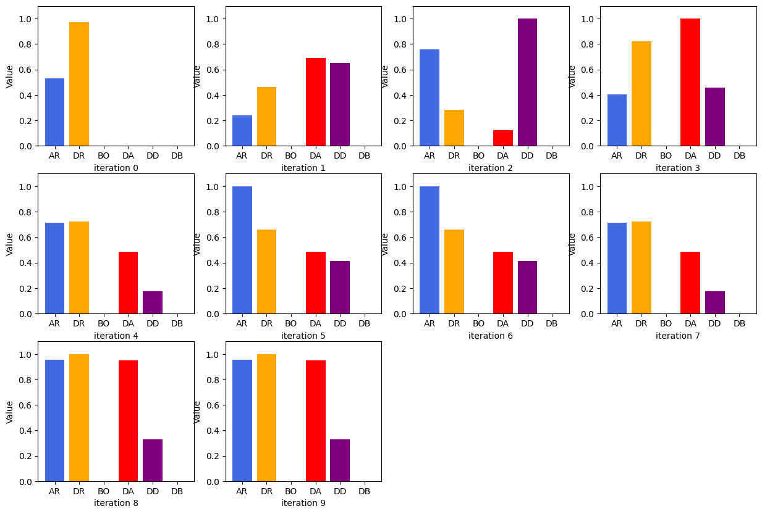

## Set: 1 (absolute)

Observation of trends

**Observation 1: GPR - scaling: multiply**

For most of the test trials, the percentage error falls beyond the preferred boundary of -2 to 2%, at around -2 to -3%, but the average transfer time is faster than the one derived in standard calibration (10s difference). Thus, in this case, the slow time penalization seemed to work. Most of the trials are repetitions but it's alright since both the time and percentage error is more or less favourable.

**Observation 2: GPR - scaling: none**

Highly repetitive sets of parameters generated, however, it seems to be because it found a set of parameters that is favourable in both the transfer time and accuracy. The transfer time is shorter than the one derived in standard calibration and the percentage error is maintained within the boundary of -2 to 2%.

Error against iteration graphs:

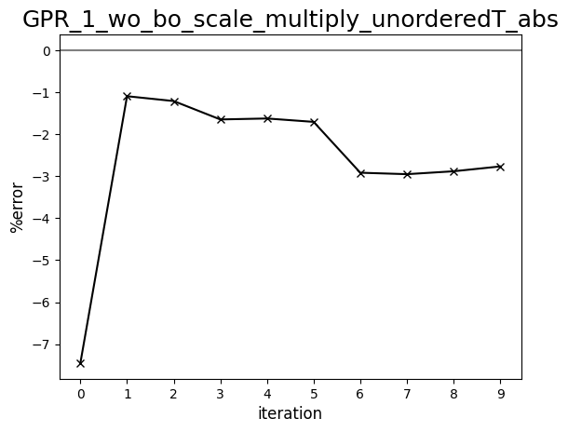

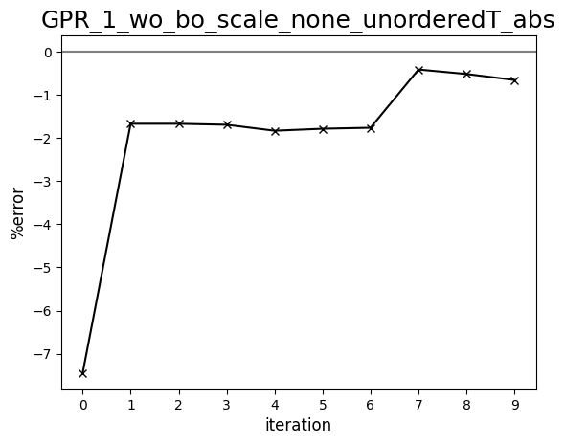

Diagram comparing human-driven and ML test trials (398 cP, set:1, absolute)

